

Course Code : CSE 404

Course Title : Software Engineering and ISD Laboratory

Experiment no: 04

Experiment name: Modeling of our Project: Use case diagrams, Class diagrams,

Sequence diagrams, Activity diagrams, DFDs

**Submitted To**

**Dr. Mohammad Zahidur Rahman**

Professor

**Dr. Md. Humayun Kabir**

Professor

Department of Computer Science & Engineering Jahangirnagar University, Savar.

Group No : 02

Group members :

|  |  |  |
| --- | --- | --- |
| **Sl** | Class Roll | Name |
| 01 | 342 | Tama Shil |
| 02 | 370 | Prokash Maitra |
| 03 | 374 | Mubasher adnan jihad |
| 04 | 375 | Pritam Saha |



Course Code : CSE 404

Course Title : Software Engineering and ISD Laboratory

Experiment no: 04

Experiment name: Modeling of our Project: Use case diagrams, Class diagrams,

Sequence diagrams, Activity diagrams, DFDs

**Submitted To**

**Dr. Mohammad Zahidur Rahman**

Professor

**Dr. Md. Humayun Kabir**

Professor

Department of Computer Science & Engineering Jahangirnagar University, Savar.

Group No : 02

Group members :

|  |  |  |
| --- | --- | --- |
| **Sl** | Class Roll | Name |
| 01 | 342 | Tama Shil |
| 02 | 370 | Prokash Maitra |
| 03 | 374 | Mubasher adnan jihad |
| 04 | 375 | Pritam Saha |

**Project name: Bus ticket booking management system**

**Name: Mubasher Adnan Jihad**

**Roll :374**

**Part: Usecase of subsystem 1,2**

**The use case of the system:**

**Subsystem-1**

**Actor:** Customer, Admin.

**Scenario:**

* Customer will Login into system.
* Customer will Register into system.
* Admin will Login into system.

**Exception:** Login page not found.

**Precondition:** Login page from web browser.

**Post condition:**

* Successful Login
* Unsuccessful Login
* Page not found.

**Use case relation:**

1. Include
2. Extends

**Use case Diagram:**

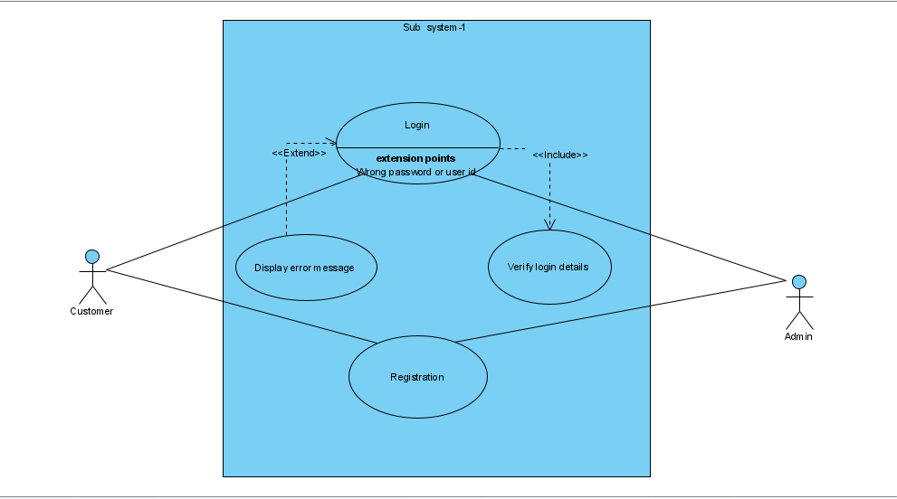

**Subsystem-2**

**Actor:** Customer, Admin.

**Scenario:**

* Customer will do the reservation of buses.
* Both Admin and Customer can send message to each other.
* Customer will do payment.

**Exception:** Wrong customer information.

**Precondition:** Only registered customer can reserve ticket.

**Postcondition:**

* Admin will get a notification about a seat being reserved.
* Customer will get a confirmation notification.

**Use case relation:**

1. Include
2. Extends

**Use case Diagram:**

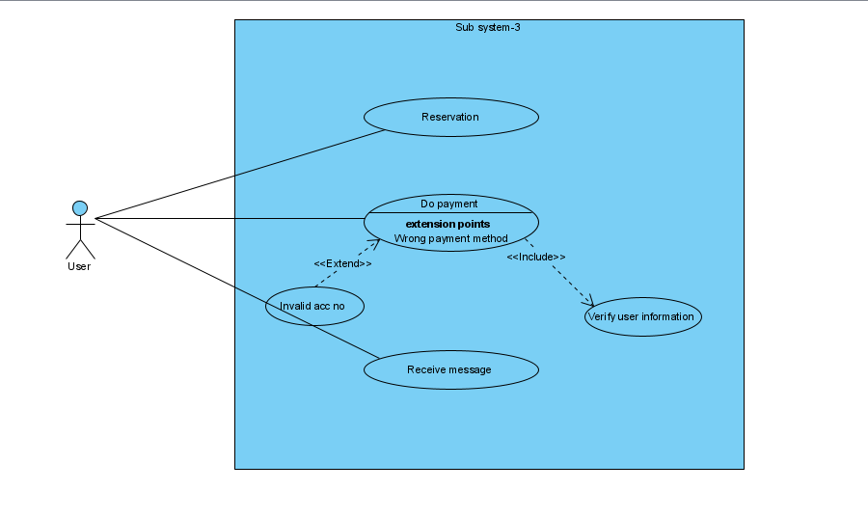

**Pritam Saha**

**Id:375**

**Part: Subsystem-3**

**Actor:** Admin.

**Scenario:**

* Admin will add bus details.
* Admin will input pickup points of all buses so that customer can select pickup points.
* Admin will input bus route and bus name so that these information can be provided to the customer.

**Exception:** Web page not found.

**Precondition:**

* Pickup points must be set according to pick up point and time.
* One time must be provided to one bus at a time.
* Route must be set according to correct route and one bus name must be provided to one bus.

**Postcondition:**

* Admin can provide one pickup time for one bus.
* Admin can provide one bus name and route at a same time.

**Use case relation:**

1. Include relation in pickup point about selecting unique time for one bus at a time.
2. Extend relation for notifying about the collision of bus.

**Use case Diagram:**

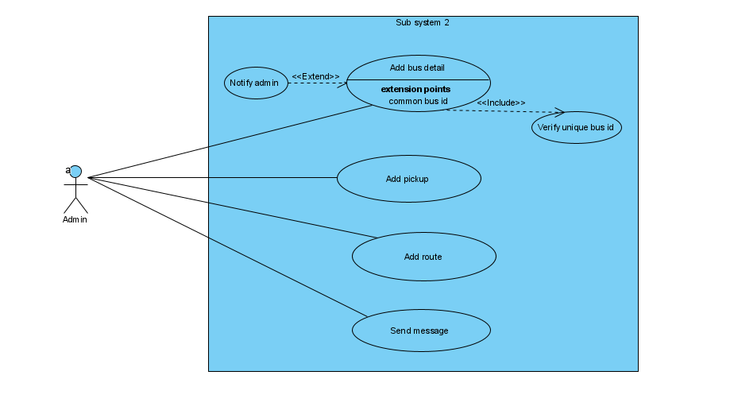

**Name**: Prokash Maitra

**Class Roll**: 370

Part:Class diagram, Sequence diagram of customer

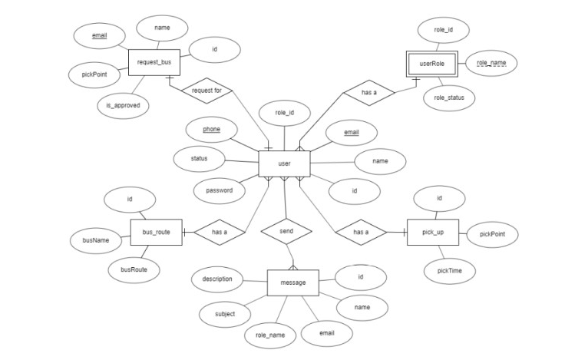

Fig:class diagram of the system



Fig: Sequence diagram of user

**Pritam Saha**

**Id:375**

**Part:Subsystem for Admin**



**Name: Tama Shil**

**ID:342**

**Part: DFD and Activity diagram for admin**

**The Data Flow Diagram (DFD) of the system:**

**Zero Level DFD:**

High level entries and process flow of Bus ticket management system:

* Managing all bus schedules
* Managing all bus reservations
* Managing all bus tickets
* Managing all bus customers
* Managing all bus routes

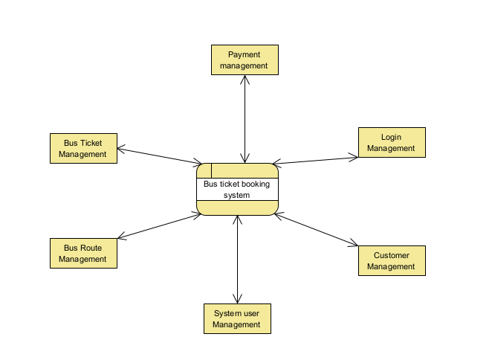

First Level DFD:

Main entries and output of first level DFD:

* Processing bus scheduling and generating reports
* Processing bus records and generating reservations reports
* Processing ticket records and generating reports
* Processing customers records and generating reports
* Processing bus routes records and generating reports
* Processing payment records and generating reports

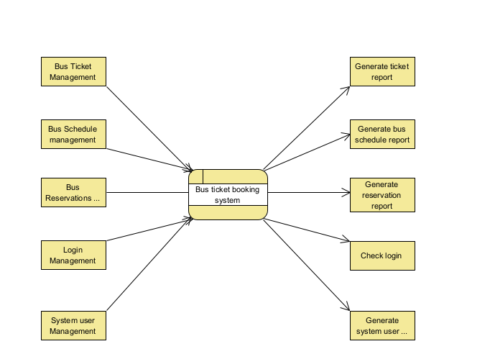

Second Level of DFD (Level 2 DFA):

Low level functionalities of bus ticket booking management system:

* Admin login to the system and manage all functionalities of bus system.
* Admin can add bus route, edit schedules, delete schedules and even view schedules.
* Admin can manage all details about ticket payments, reservation cancellations, booking details, customer details.
* Admin can search the details of booking customers details
* Admin can track detailed information of booking, tickets and customers

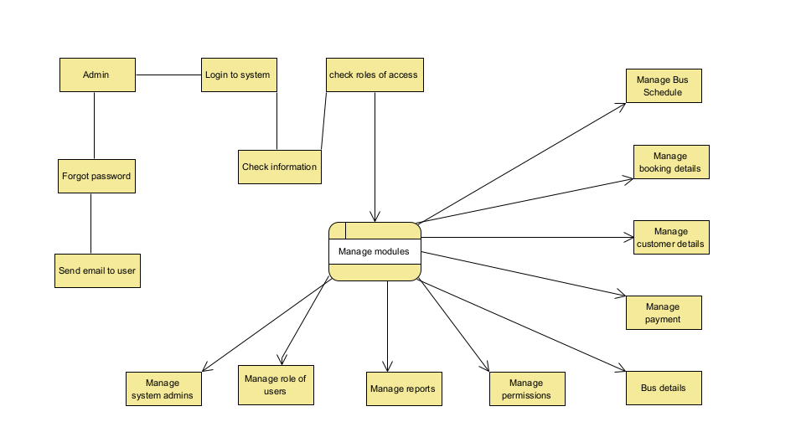

**Activity Diagram for admin:**



**Activity Diagram for user:**

